Lab 1 task 3: Log In to vCenter Server with the vSphere Client

Using the vSphere Client, you log in to the sa-vcsa-01.vclass.local vCenter Server system and view information to familiarize yourself with the UI layout.

1. From your student desktop Student-a-01, log in to sa-vcsa-01.vclass.local as administrator@vsphere.local using the vSphere Client.

- From the bookmarks toolbar, select vSphere Site-A > vSphere Client (SA-VCSA-01).
- Log in by entering administrator@vsphere.local as the user name and VMware1! as the password.

The vSphere Client opens, and the Home page appears.

2. On the Home page, select SA-VCSA-01.VCLASS.LOCAL from the drop-down menu at the top.
This page provides information about the vCenter Server instance that you are logged into, such as the total CPU, memory, and storage available.

3. From the Menu drop-down menu, select Hosts and Clusters.

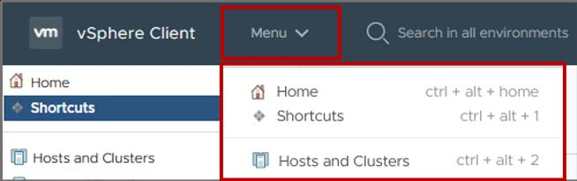

The Hosts and Clusters inventory appears in the left pane, also called the navigation pane.

4. View the navigation pane.

The navigation pane lists the vCenter Server inventory for sa-vcsa-01.vclass.local.

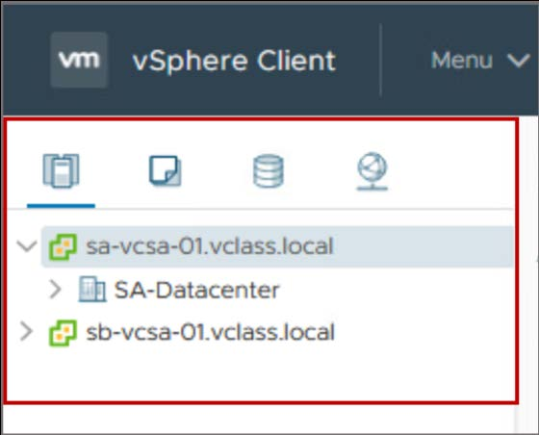

5. View the items in the inventory.

You might have to expand the items in the inventory to view al the objects.
Q1. Do you see the sa-esxi-01.vclass.local host?

6. Log out of the vSphere Client.

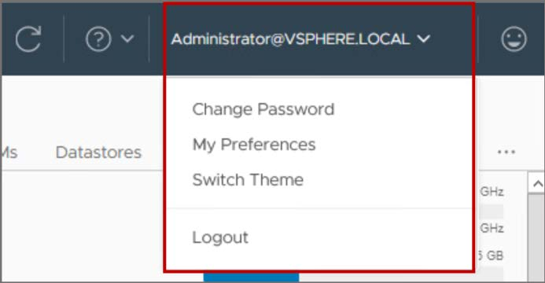

The logout function is in the Administrator@VSPHERE.LOCAL drop-down menu at the top-right corner of the window.

